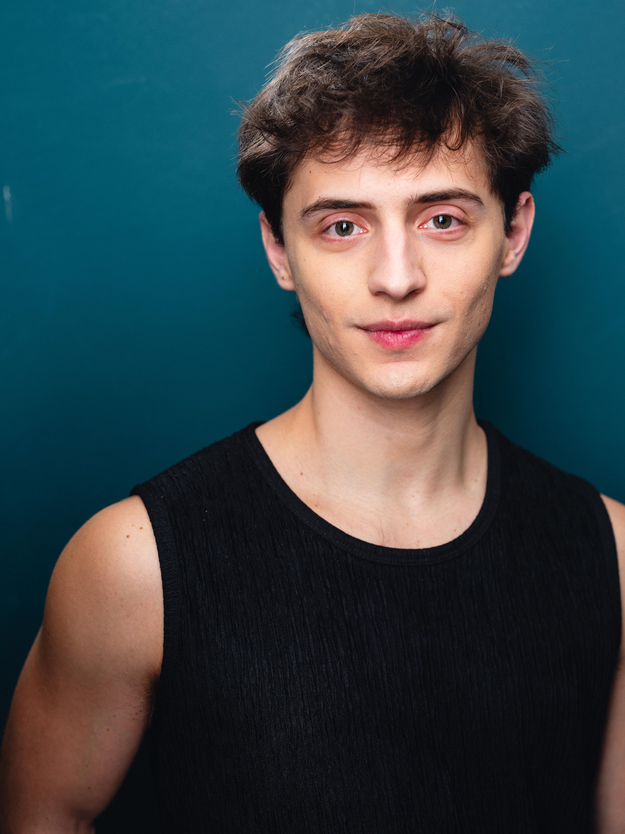 **Dominic Young**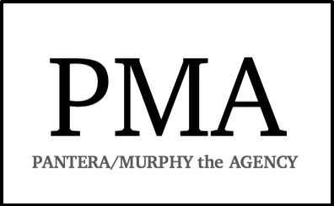

*(He/Him/His)*

*EMC*

dominicyoung.com

*domyoung260@gmail.com*

*Height: 5’9” Voice: G2-B4*

**THEATER**

*Hairspray* Link Larkin Theater by the Sea Christopher Campbell

*American Idiot: The Musical* Johnny Short North Stage Edward Carignan

*Jesus Christ Superstar* Peter U/S Judas Porthouse Theater Terri Kent

*West Side Story* Baby John Porthouse Theater Terri Kent

*The Prom* Kevin U/S Trent Porthouse Theater Terri Kent

*A Funny Thing… Forum* Ens. U/S Hero Porthouse Theater Terri Kent

**EDUCATIONAL THEATER**

*Rent* Roger Kent State University Amy Fritsche

*Cabaret* Emcee Kent State University Terri Kent

*Urinetown* Hope Kent State University Danny Loftus-George

*The Wedding Singer* Robbie Hart The Naples Players Dawn Fornara

**DANCE**

*Together Apart* Contemp. Duet Kent State University Catherine Meredith

*En Contretemps* Pas de Quatre Kent State University Jeffrey Rockland

**TRAINING / EDUCATION**

BFA-MT and Dance Minor at Kent State University *Voice:* Tim Culver, Charles Fornara

*Instruments:* Trumpet (Dan Miller) (pit orchestra credits), Piano (Int.), Guitar (Int.), Trombone (Int.)

**SPECIAL SKILLS**

*Voice Type:* Tenor (with low notes) *Dance styles:* Jazz, Ballet, Modern, Partnering, Tap

Walking on hands. Reading music. Weight Lifting. Dolphin calls. Siri voice. Juggling. The Worm. Playing Catan. NREMT and CPR Certified. Rock Climbing Belay Certified.